**Refreshments**

Refreshments are provided by members at all meetings and members assist with setting up and cleaning up. The first letter of your last name determines the monthly meeting for which you are requested to support refreshments. Members providing refreshments will receive an additional raffle ticket for the meeting raffle. Be sure to mention this upon check-in!

**April Refreshments: Q through T**

Nancy Spirito is our Refreshments Chairperson and may be contacted at:

[bridalfinerydesign@gmail.com](mailto:bridalfinerydesign@gmail.com)

**For Sale or Free**

Did the urge to purge your sewing stash

strike as the weather warmed? Members are

invited to set up a table at our meetings to sell

or give away sewing/craft related items.

Have a sewing/craft related business? Why

not consider showcasing/selling your items at a

meeting? Please limit your selling space to one

table.

**DIRECTIONS TO GREENWICH CLUB**

**From the South**: Take 95 North to exit 8A (Rt. 2 Warwick/E. Greenwich). Stay on Rt.2, go to the traffic light at the Showcase Cinema, take a left onto Division Street (Rt. 401), follow to 2nd traffic light, and take right onto Post Road/Rt. 1. The Greenwich Club, 5426 Post Road, is on your left.

**From the North**: Take 95 South to exit 9 (Rt. 4 South). Take the first exit which will bring you to Rt. 401 (E. Greenwich/Division St.). At the end of the exit ramp facing straight, take a right turn onto Division Street. **Continue to follow above directions once on Division Street.**

**Executive Board**

**EXECUTIVE SECRETARY**

Mary Jo Hines

(401-785-9001

[maryjo.hines@gmail.com](mailto:maryjo.hines@gmail.com)

**TREASURER/REGISTRATIONS**  
Ann Pericolo

(508-846-5456)

[AnnPericolo@yahoo.com](mailto:AnnPericolo@yahoo.com)

**NEWSLETTER MAILINGS**  
Mary Morse  
( 401-821-7467)

[memorse@yahoo.com](mailto:memorse@yahoo.com)

**PROGRAM CHAIRPERSON**  
Diane Martin  
(401-762-0960)

dianemartin426@gmail.com

**NEW YORK TRIP**

Michele Ferguson

(401-845-2069)

micheleferguson81@yahoo.com

**REFRESHMENTS CHAIRPERSON**  
Nancy Spirito

(401-965-6556)

[bridalfinerydesign@gmail.com](mailto:bridalfinerydesign@gmail.com)

**WEB ADMINISTRATOR**  
Maureen Rozes

(401-855-5885)

[maureenrozes@yahoo.com](mailto:maureenrozes@yahoo.com)

**FACEBOOK ADMINISTRATOR**

Robbin Donahue

[robbindonahue@gmail.com](mailto:robbindonahue@gmail.com)

**NAME TAGS/MEMBERSHIP CARDS**

Susan Love

(401-595-1160)

[SchoolHouseStudio@verizon.net](mailto:SchoolHouseStudio@verizon.net)





**April Meeting**

**April 3, 2018**

Please join RISN for our April program “Process*: Inspiration to Runway; Making a Collection with Custom Textiles and Hand-dyed Fabrics”* with presenter Susan Troy. Susan Troy is a clothing and textile designer living in Rhode Island. A 2005 graduate of University of MA with a BFA in textile design, she studied apparel design at the School of Fashion Design in Boston and participated in several Styleweek Northeast events.

Inspired by nature and architecture, Susan is an extraordinary technician both as an artist and tailor. This is evident in her initial drawings, custom textile design and garment construction. Her most recent collection is an ode to the historical imageries of the 1930’s Dust Bowl. Susan’s original painted floral dress and hand-stitched wool coat, from this collection, were inspired by depression-era styles.

Susan continues to paint her unique textile designs and hand-dyed fabrics. Drawing inspiration from flowers, textures, and stitching, Susan does it all through the sketching process to colorways/dye mixtures to surface design to fabric selection to stitching details to final construction.

For her program, Susan will share her process from start to finish including inspiration board, dye notebook, sketchbook, fabric swatches, and final collection.

**March Show and Share**

Michelle Ferguson shared information regarding the June RISN sponsored day trip to the New York City Fashion District. Michelle also is seeking suggestions for other sewing related trips that could be sponsored by RISN.

In a nod to our November program, Jan Fletcher shared an 1890’s sleeve board which she rescued from her aunt’s house. Mary Jo Hines showed a service project preemie vest with a stitch and turn finish. Diane inspired many to register for the New York trip with her wedding ensemble made from fabric purchased at B and J’s Fabric in New York City. Diane enjoys looking for unique fabrics on her New York fabric shopping excursions. Denise Carlson is enjoying her embroidery machine and shared bibs which she made from toweling for her grandchildren embroidered with cute sayings from embroiderylibrary.com. Denise also shared a shower wrap which she plans to wear at the YMCA which she draped on her dress form. Donna Miller shared a skirt which she made after taking a Craftsy class. The skirt was layered with two shades of teal which was cut away to create a design. The skirt also had a matching top. Donna was busy and also showed a tote bag which she created from a feed bag. She ended with an 80” by 80” quilt top which made by hand for her daughter’s marriage using the English paper piecing technique. Donna Mansollilo closed our Show and Share with a beautiful Asian inspired jacket which she made in the MS Specialty Fabric class. She used Butterick 4688.

Special thanks to Alex Allardt for taking the Show and Share photos!

(Note: When presenting at Show and Share please state your name and include resource information for the newsletter.)

**RISN Meetings**

**GREENWICH CLUB**

**5426 Post Road**

**East Greenwich, Rhode Island**

**02818**

**First Tuesday of the Month**

**@ 7:00 pm**

**֎ ֎ ֎ ֎ ֎**

**RISN 2017-2018**

**Future Meeting Dates and Presenters**

**April 3, 2018 "Process: Inspiration to Runway; Making a collection with custom textiles and hand-dyed fabrics”** Susan Troy

**May 1, 2018 "Orange Lingerie”**

Norma Lochr; [norma@orange-lingerie.com](mailto:norma@orange-lingerie.com)

**New York City Shopping Trip**

**June 6, 2018**

**֎ ֎ ֎ ֎ ֎**

**March Program Highlights**

Our March program, “*Sewing for Historic Interiors”* was presented by Clarissa DeMuzio. Clarissa learned to sew from her mother and grandmother but received her formal training at the Philadelphia College of Textiles and Science.

Clarissa described her research process to determine appropriate designs and textiles for her client’s projects. She shared several text sources but noted “Textiles in America; 1650 – 1870” by Florence M. Montgomery as her “Bible”. Although books are a great resource to find and execute period appropriate design, Clarissa shared that art can provide clues to textile use and design in furnishings. She is fortunate to have access to authentic, historic 18th and 19th century textiles and furnishings from which she is able to study construction techniques.

During her presentation, Clarissa gave many examples of historic textile use in historic furnishings, described the construction techniques involved, and indicated the type of textile used. She uses Cordonnet thread and a Bohin beading type needle for her hand stitching.

To close her program, Clarissa extended a request for assistance with a personal project. Clarissa has collected over a thousand pieces of printed craft panels. She is seeking information on the history of the panels and about the artists who created the panels. Clarissa may be contacted by email at cdemuzio@me.com.

**RISN Service Project Update**

Mary Jo Hines asks members to keep working on the Preemie Vests for donation to NICU at Women and Infants Hospital. Completed vests can be brought to any RISN meeting. All Preemie Vests should be turned in by the May meeting. Please contact Mary Jo for a pattern and instructions.

**New York City Shopping Trip**

**June 6, 2018**

Looking for unique fabric and notions? The New York City fabric district abounds with places to purchase unique items to add to your stash and spark your creative sewing imagination. Please see the attached New York Trip registration form. The deadline to purchase tickets will be May 11, 2018. A minimum of 20 people must attend to run the trip.

C:\Users\mary\AppData\Local\Temp\WP_20180306_19_19_04_Pro.jpg

Donna Mansolilo

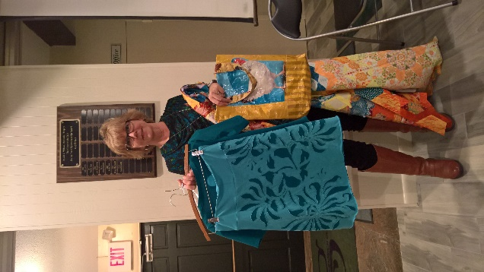

Donna Miller

**Show and Share Photos**

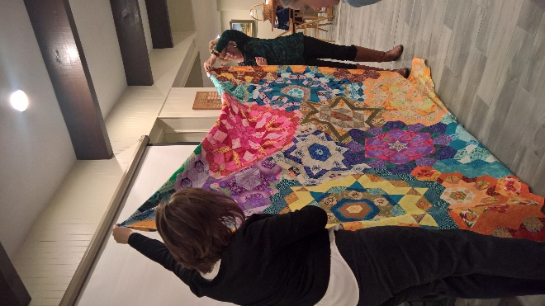

Donna Miller

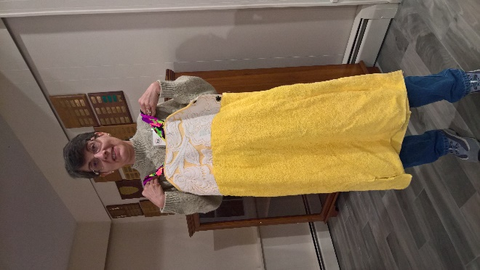

Denise Carlson

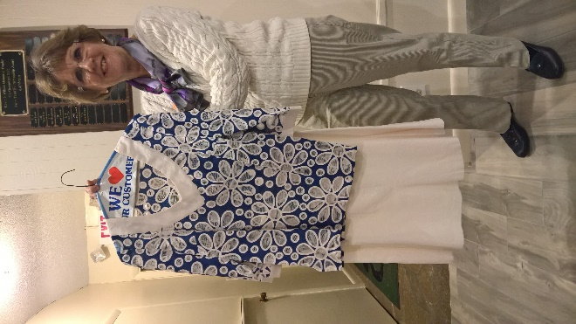

Diane Martin

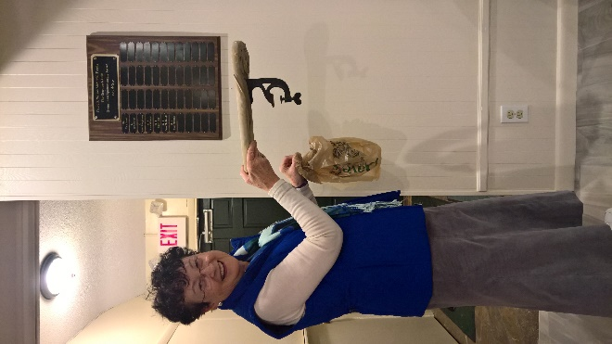

Jan Fletcher