Rhode Island Sewing Network
April Newsletter
RISN Meetings  GREENWICH CLUB  5426 Post Road  East Greenwich, RI  02818  First Tuesday of the Month  @ 7:00 pm  ֎֎֎֎֎֎֎֎֎֎֎  DIRECTIONS TO GREENWICH CLUB  From the South: Take 95 North to exit 8A (Rt. 2 Warwick/E. Greenwich). Stay on Rt.2, go to the traffic light at the Showcase Cinema, take a left onto Division Street (Rt. 401), follow to 2nd traffic light, and take right onto Post Road/Rt. 1. The Greenwich Club, 5426 Post Road, is on your left.  From the North: Take 95 South to exit 9 (Rt. 4 South). Take the first exit which will bring you to Rt. 401 (E. Greenwich/Division St.). At the end of the exit ramp facing straight, take a right turn onto Division Street. Continue to follow above directions once on Division Street.  RISN  Executive Board  EXECUTIVE SECRETARY  Mary Jo Hines  (401-785-9001)  maryjo.hines@gmail.com  TREASURER/REGISTRATIONS  Ann Pericolo  (508-846-5456)  AnnPericolo@yahoo.com  NEWSLETTER MAILINGS  Rose O’Koren  (508-528-1663)  okorenj@comcast.net  PROGRAM CHAIRPERSON  Diane Martin  (401-439-5376)  dianemartin426@gmail.com  SPECIAL EVENTS  Michele Ferguson  (401-845-2069)  micheleferguson81@yahoo.com  REFRESHMENTS CHAIRPERSON  Nancy Spirito  (401-965-6556)  bridalfinerydesign@gmail.com  WEB ADMINISTRATOR  Maureen Rozes  (401-855-5885)  maureenrozes@yahoo.com  FACEBOOK ADMINISTRATOR  Susanne Walter  860-885-9859  Sueann301@yahoo.com  Mary Morse  401-821-7467  memorse@yahoo.com  NAME TAGS/MEMBERSHIP CARDS  Michele Ferguson  (401-845-2069)  micheleferguson81@yahoo.com | April Meeting  April 2, 2019  The April program will be It’s All Fabric! by RISN member Ruth Gross. After earning an art degree at Mississippi University for Women, Ruth moved to New York City where she worked for a clothing and craft pattern company. Upon relocating to Lakeville, Massachusetts, she sewed theatrical costumes for Stonehill College and Red Curtain Rentals.  In 2008, Ruth began It’s All Fabric! designing quilted wall hangings, lecturing and leading quilting workshops. She created six appliqué quilts for the National Catholic Bishops Symposium for Minorities (on display at their Washington headquarters), designed/quilted a banner for the Upper New York State Council of Native Nations and was the featured artist at the Lakeville Arts and Music Festival. Following her one-woman gallery exhibit of stained glass quilts in 2010, her next challenge was using raw edge appliqué to create realistic fabric pictures. Beginning with a folk-art style house portrait, the effort to add shadows and perspective, find interesting angles and "turn fabric into paint" made this challenge an obsession. Lakeville's beautiful historic buildings were subjects for Ruth's Lakeville Landmarks Collection. These quilts along with fabric portraits were included in People and Places, her one-woman exhibit in 2018.  Ruth looks forward to explaining the process of preparing the drawings - easier than you would think using technology (for the barely tech savvy). She will give suggestions and sources for buying fabrics, describe her method of layering the design and quilting the pictures, and suggest techniques for finishing the pieces.  Meeting Dates and Presenters  May 7, 2019 - Sherit Levin showing “Hand Painted Velvet Devore Scarves & Shawls”  Theme for this year: Embellishments for Show & Share  What have you embellished this year? Have you embroidered anything? Added a cool trim to a dress or jacket? Where did you get those cool buttons that made that coat pop? This year we are focusing on bringing our sewing to a new level with our speakers who specialize in Embellishments. Let’s challenge ourselves to be more creative in our sewing. We can’t wait to see your Sew and Share at our meetings.  Refreshments  April Refreshments: R - U  Nancy Spirito is our Refreshments Chairperson and may be contacted at: bridalfinerydesign@gmail.com  Refreshments are provided at all meetings and members provide the baked goods or appetizers as well as help with setting up and cleaning up. RISN uses a calendar for members to follow to provide refreshments. The first letter of your last name determines the monthly meeting for which you are requested to support refreshments. Members providing refreshments will receive an additional raffle ticket for the meeting raffle. Be sure to mention this upon check-in!  Facebook Group – RISN Exclusive  As a member of the Rhode Island Sewing Network you have exclusive rights to join our new private Facebook group. The name of the group is: RISN Exclusive and it is limited to registered RISN members only. Through participation on this Facebook page, we will get to know each other better, support one another in our sewing endeavors, and share our projects. No Facebook experience is necessary! We are all here to help each other along. This is an exclusive group so you can only join by invitation. If you are on our newsletter email list, we will send you a link where you can request to join.  Check out our Facebook page, members have added great videos and pictures.  MEMBERSHIP INFORMATION  Attached to this email with your newsletter is your 2018-2019 RISN membership application form. Your completed application with a check made out to RI Sewing Network or RISN should be mailed directly to:  Ann Pericolo  10 Cherry Street  Wrentham, MA 02093  Membership cards for members who sign up prior to the meeting will be handed out at the October meeting. Anyone not attending the October meeting will receive their membership card in the mail.  Membership includes six issues of our newsletter plus discounts to meetings and other events as well as email news.  1. Annual Membership is $10.00 and each of the six scheduled meetings is $5.00 for each meeting attended. The nonmember fee for meetings is $7.00 per meeting.  2. Premiere Membership is $30.00 equal to six scheduled meetings. With this Premiere Membership, the $10.00 membership fee is waived and there are no additional fees for attending meetings. In addition, you can bring one guest to one meeting for free.  The Registration form is on our website: www.rhodeislandsewingnetwork.com  For Sale  Urge to Purge? Members who have sewing/craft items for sale are invited to set up a table at our meetings.  Have a sewing/craft related business? Why not consider showcasing/selling your items at a meeting? Please limit your selling space to one table.

At our last meeting in March
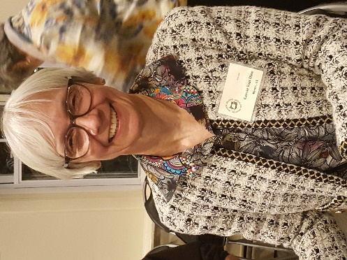 Cassie Van Dine spoke about Understanding your Machine Feet and How to Use Them. Cassie is a Martha Pullen licensed teacher for heirloom quilting and heirloom sewing. She is a graduate of Master Seamstress I and II. She has also completed moulage, jacket and skirt courses with Kenneth King. Cassie is now a URI Master Seamstress II instructor offering classes in Shirtmaking and Contemporary Tailoring.
Cassie explained how our machines worked and what different feet were for. Who knew that sewing machine feet wear out. Check to make sure the feet you buy are for the correct shank for your machine.

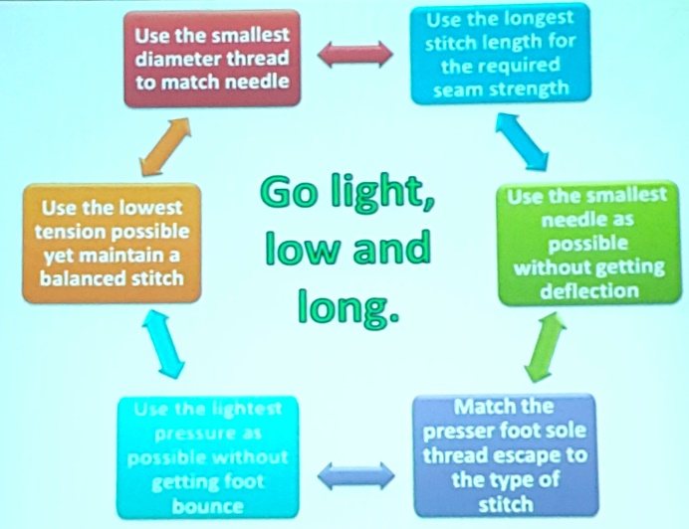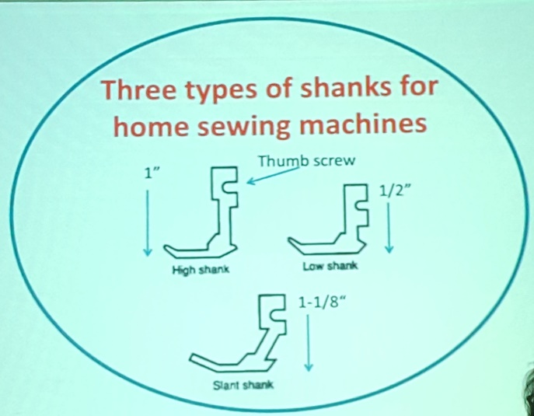

.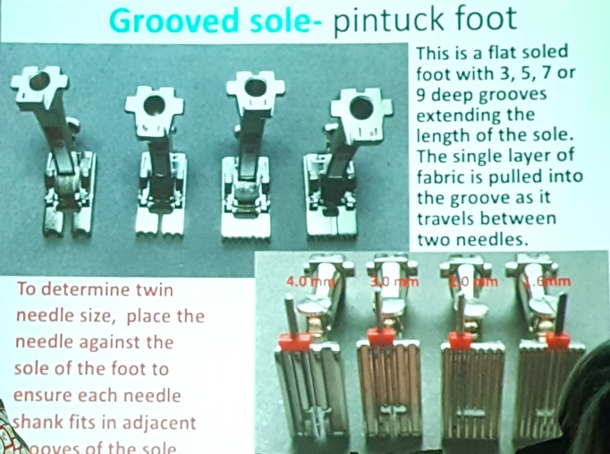 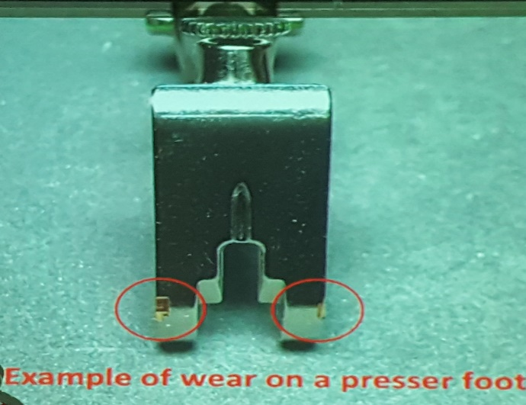

Sew and Tell

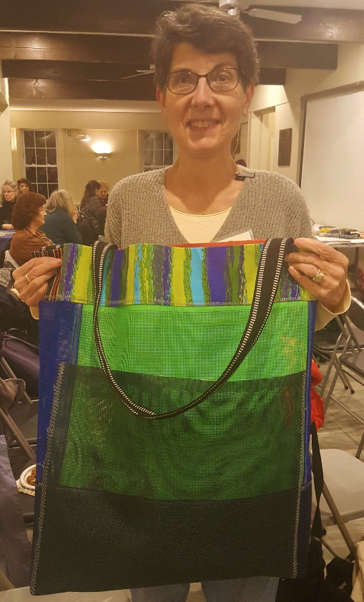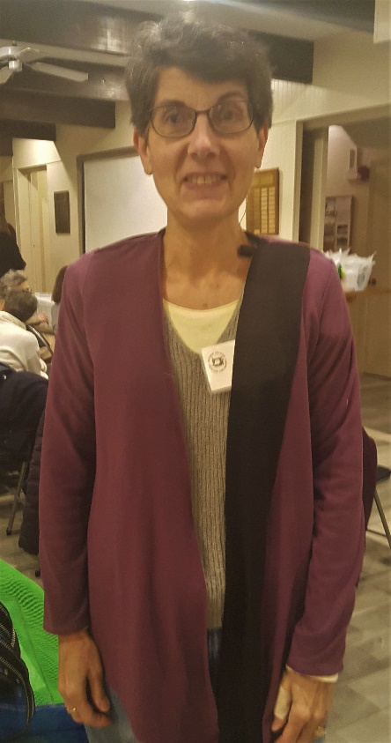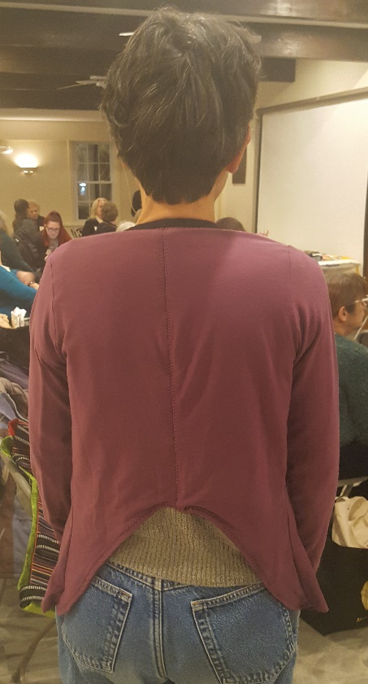
Denise Carlson
Made a mesh bag with many pockets for the swim accessories and this top from a
Jen Stern pattern. Thank you for everyone on Facebook helping with this top.

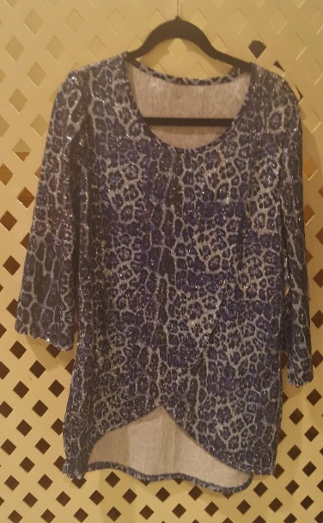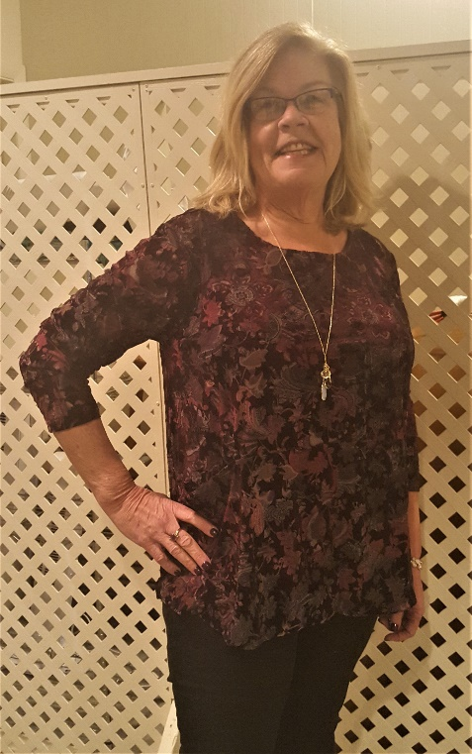

Nancy Hoell
Made two tops: Vogue 9332 and McCall’s 7247

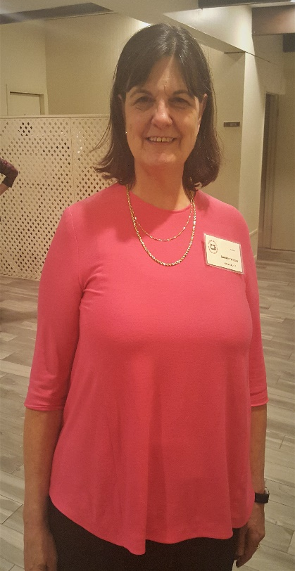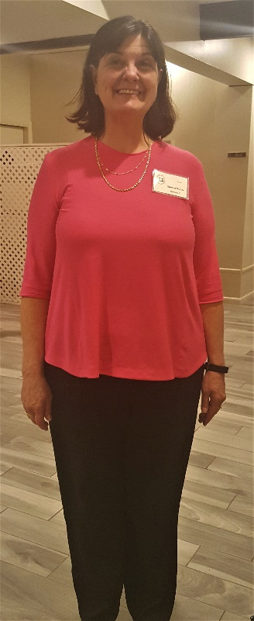
Sueanne Walter
Made her top and pants, she didn’t want to model during Sew and Tell.

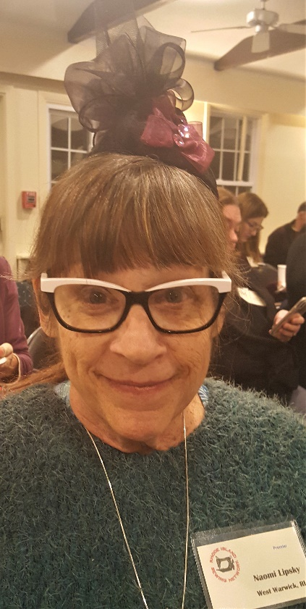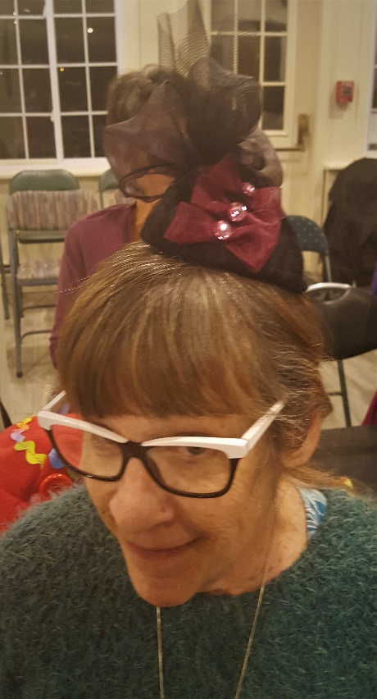
Naomi Lipsky
Made this hat for Tea Luncheon.
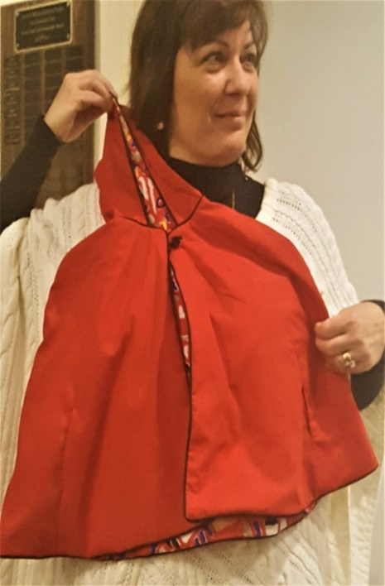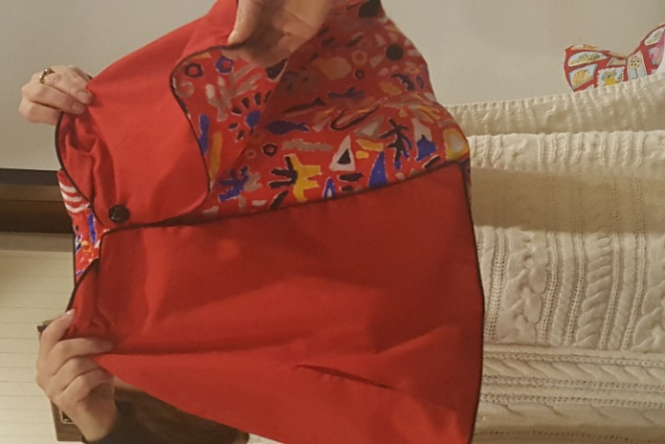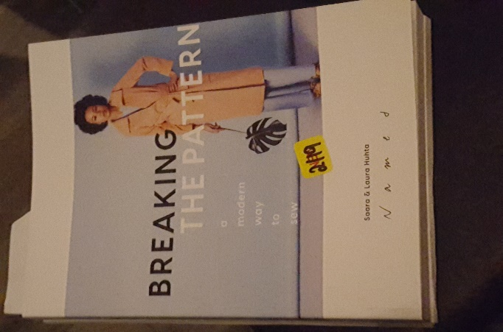
Donna Massolillo
She is not pictured, made a child’s cape with the help of this book, “Breaking the Pattern, a modern way to sew”, by Saara & Laura Huht

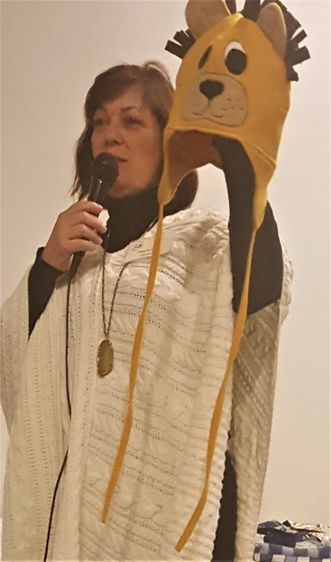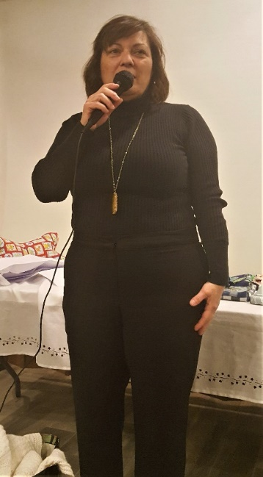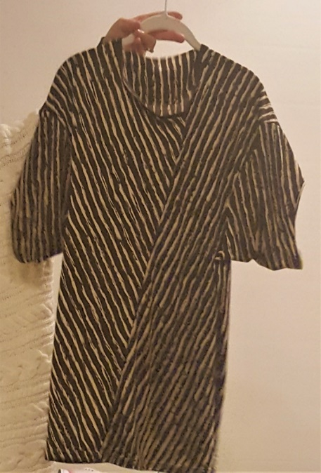
Mary Jo Hines
Made cute kids’ hats, pants from the Pants Drafting Class and on piece top that was a uniquely cut.

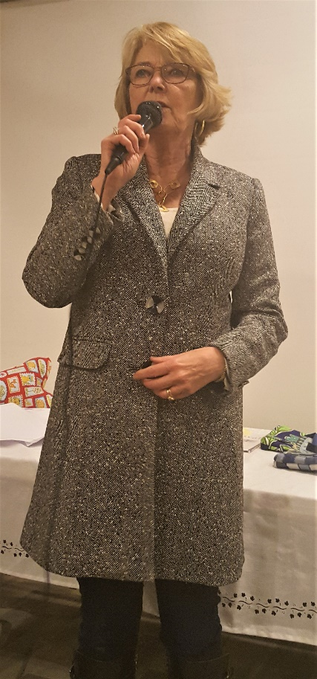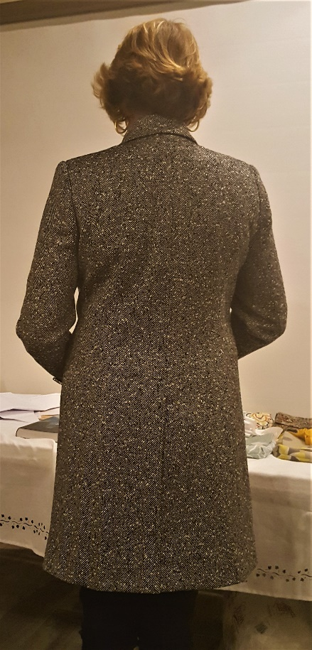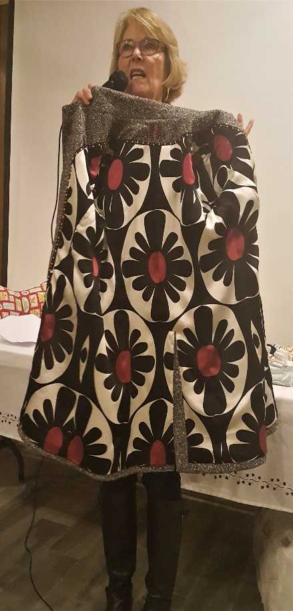
Jane Headley
This is from the Master Seamstress I Tailor “Jacket” class. Jane worked hard on matching the lining design.

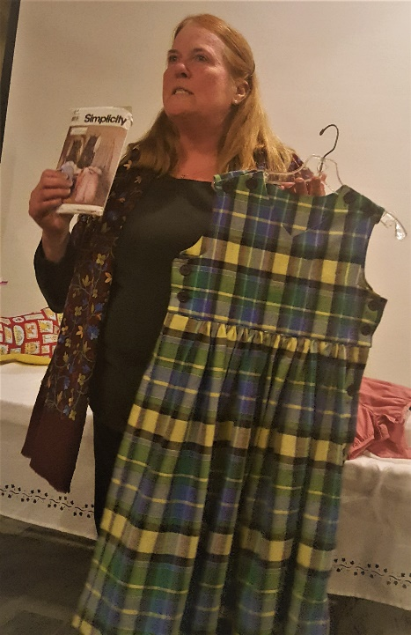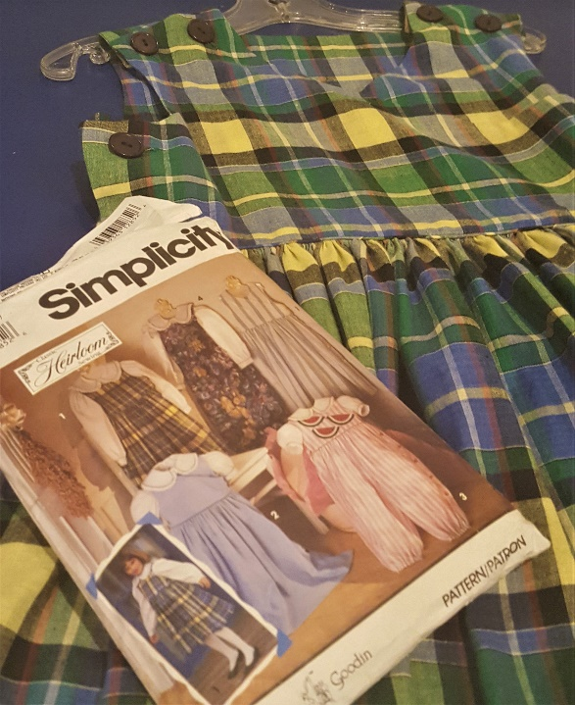
Kathy Dacey
Started this dress when her daughter was in elementary school. I think her daughter is a now a practicing lawyer. Another “UFO”, unfinished object, done !!!!

More of Kathy Dacey’s handiwork
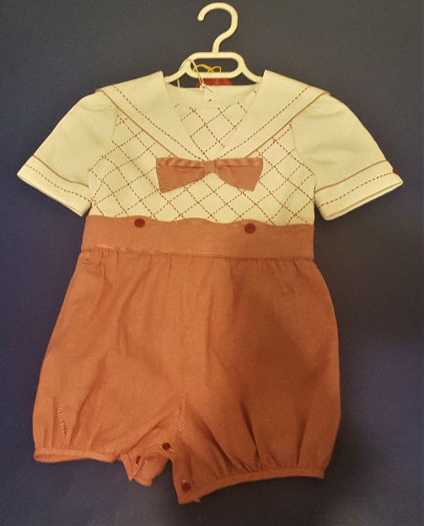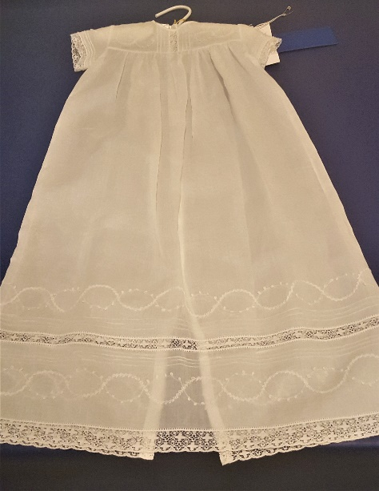

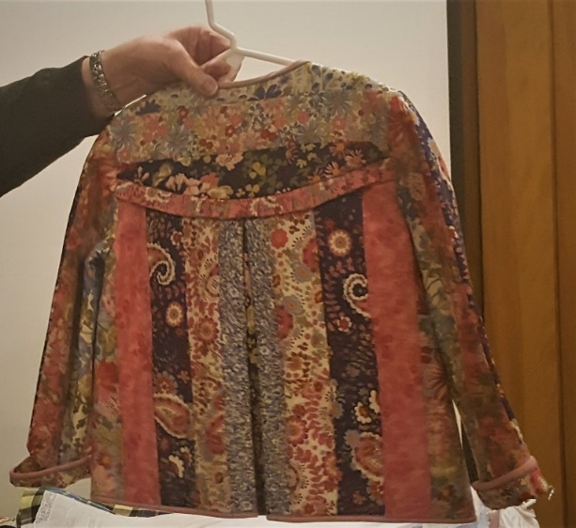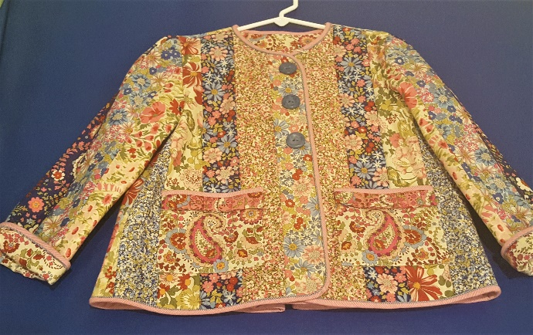

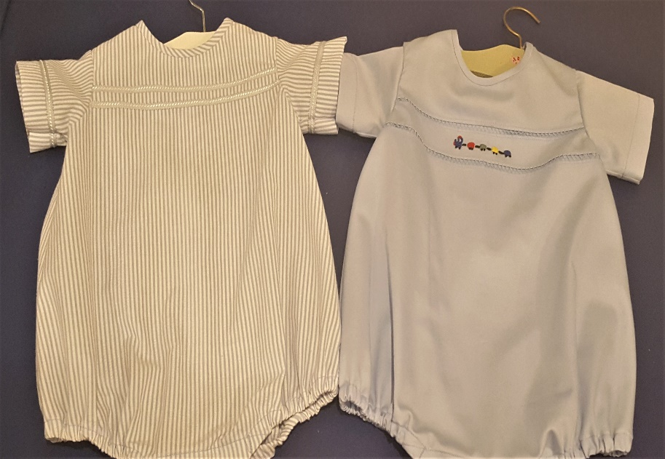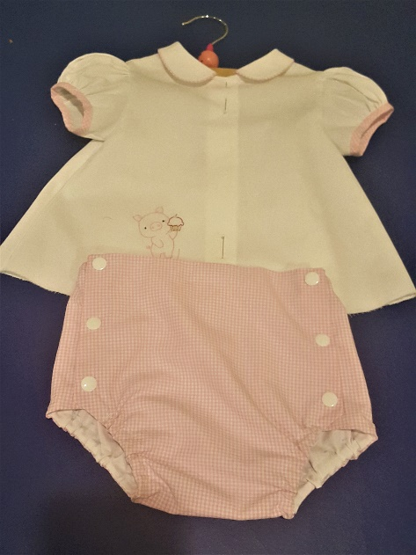
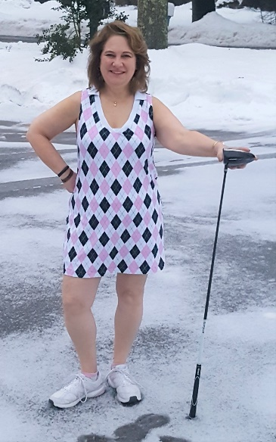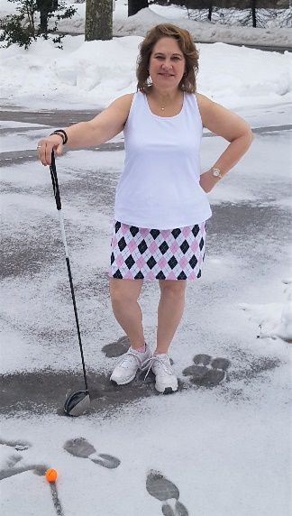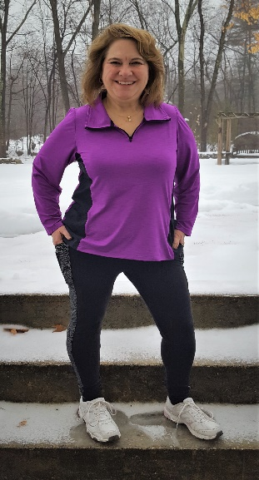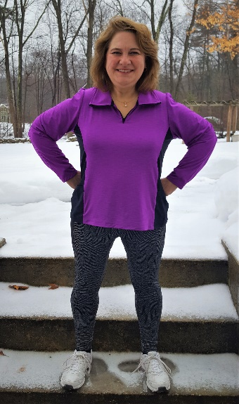
Rose O’Koren
All these patterns are from Greenstyle Creations. The dress is the Tee Shirt lengthened to dress length. There are Compression shorts underneath. The Skort is the Pacer Skort. She cut out the front twice because of the knit fabric. The Super G leggings are colored blocked and the top is the Pacific Pullover. Both the leggings and the top have pockets on the sides.

The bag is a reversable “leather” bag from Walmart that she embroidered on.
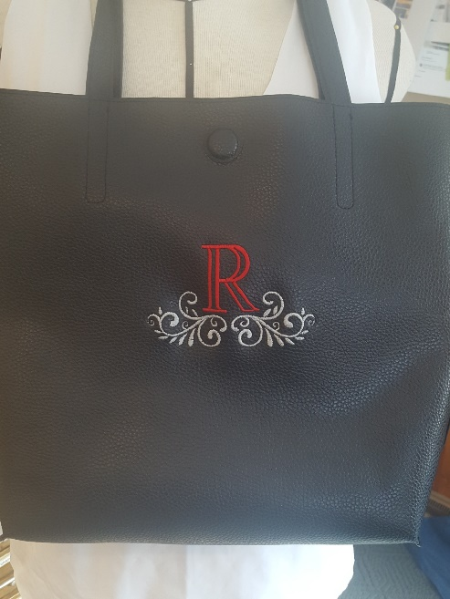

Please tell me before the meeting that you have something to show for Sew and Tell so I can take a good picture of you before the meeting, I want to take a nice picture of your creations and of you. I am trying to take pictures and listen your story and somethings it is hard. I do not want to interrupt your presentation while I am trying to take a nice picture of you.
Thanks for your cooperation.

