**Refreshments**

Refreshments are provided by members at all meetings and members assist with setting up and cleaning up. RISN uses a calendar for members to provide refreshments. The first letter of your last name determines the monthly meeting for which you are requested to support refreshments. Members providing refreshments will receive an additional raffle ticket for the meeting raffle. Be sure to mention this upon check-in!

**December Refreshments: I through L**

Nancy Spirito is our Refreshments Chairperson and may be contacted at:

[bridalfinerydesign@gmail.com](mailto:bridalfinerydesign@gmail.com)

**For Sale or Free**

Wondering how to make space in your sewing room for your anticipated holiday sewing gifts? Members are invited to set up a table at our meetings to sell or give away sewing/craft related items.

Have a sewing/craft related business? Why not consider showcasing/selling your items at a meeting? Please limit your selling space to one table.

**DIRECTIONS TO GREENWICH CLUB**

**From the South**: Take 95 North to exit 8A (Rt. 2 Warwick/E. Greenwich). Stay on Rt.2, go to the traffic light at the Showcase Cinema, take a left onto Division Street (Rt. 401), follow to 2nd traffic light, and take right onto Post Road/Rt. 1. The Greenwich Club, 5426 Post Road, is on your left.

**From the North**: Take 95 South to exit 9 (Rt. 4 South). Take the first exit which will bring you to Rt. 401 (E. Greenwich/Division St.). At the end of the exit ramp facing straight, take a right turn onto Division Street. **Continue to follow above directions once on Division Street.**

**Executive Board**

**EXECUTIVE SECRETARY**

Mary Jo Hines

(401-785-9001

[maryjo.hines@gmail.com](mailto:maryjo.hines@gmail.com)

**TREASURER/REGISTRATIONS**  
Ann Pericolo

(508-846-5456)

[AnnPericolo@yahoo.com](mailto:AnnPericolo@yahoo.com)

**NEWSLETTER MAILINGS**  
Mary Morse  
( 401-821-7467)

[memorse@yahoo.com](mailto:memorse@yahoo.com)

**PROGRAM CHAIRPERSON**  
Diane Martin  
(401-762-0960)

dianemartin426@gmail.com

**NEW YORK TRIP**

Michele Ferguson

(401-845-2069)

micheleferguson81@yahoo.com

**REFRESHMENTS CHAIRPERSON**  
Nancy Spirito

(401-965-6556)

[bridalfinerydesign@gmail.com](mailto:bridalfinerydesign@gmail.com)

**WEB ADMINISTRATOR**  
Maureen Rozes

(401-855-5885)

[maureenrozes@yahoo.com](mailto:maureenrozes@yahoo.com)

**FACEBOOK ADMINISTRATOR**

Robbin Donahue

[robbindonahue@gmail.com](mailto:robbindonahue@gmail.com)

**NAME TAGS/MEMBERSHIP CARDS**

Susan Love

(401-595-1160)

[SchoolHouseStudio@verizon.net](mailto:SchoolHouseStudio@verizon.net)





**December Meeting**

**December 5, 2017**

Have you ever worked with an exquisite natural fabric, such as silk shantung or a fine linen weave, and wondered how this incredible product of nature came to be in your hands? Join RISN for our December program “*The Origin of Linen, Cashmere and Silk and the Art of Garment Grooming”* as we explore the origin and the characteristics of three ancient textiles: linen, cashmere and silk, and how to care for them in our modern world. Reed McLaren, our program presenter and owner of THE HOUSE OF AMA, has been building a following by offering the beauty and benefits of vintage and designer garments made of exquisite natural materials. She will share her knowledge and demonstrate the grooming techniques that she uses to polish her garments. A collection of classic chic and statement pieces will be on display and available for purchase.

Reed attended the Lyme Academy of Fine Arts and studied voice and harp at RI College, specializing in Early and World music. She has exhibited with and worked on the boards of local art groups, including the Art League of RI, and led a volunteer project to raise funds and renovate a gallery space for a non-profit in Cranston, RI, and has curated multiple community focused art exhibitions. While she draws from all of these creative experiences and endeavors to build THE HOUSE OF AMA, Reed states that her knowledge of fashion and textile history and arts is self-taught, originating through personal appreciation, zeal for collecting, and a thirst for knowledge.

[www.facebook.com/THEHOUSEOFAMA/](http://www.facebook.com/THEHOUSEOFAMA/) [www.instagram.com/thehouseofama/](http://www.instagram.com/thehouseofama/)

**November Show and Share**

Rose O’Koren shared a dress for her daughter and a lap quilt. Mabel Wagner modeled her latest tailored jacket which was fitted by Diane Martin. Patricia Keenan wore a beautiful brown, long shrug with fabric from Gorgeous Fabrics. Donna Boucher modeled an exquisite 3D hand embroidered and beaded fall scarf from a Jan Curtain class held at Sewing at the Beach. Donna Mansolillo wore her MS tailored jacket made with fabric from Sewphisticated Fabrics. Denise Carlson shared a wall-hanging made from Bloomin’Minds pattern 551 called “My Sister”. Carolyn Gazzero was stylish in her leopard print vest with rhinestone zipper. Carolyn also completed the project she showed at last meeting.  A black on black striped fabric jacket was trimmed with stretch lace fabric. Pellon Wonder Under was applied to the lace strips.  When pressed with a cloth the residue from the open fabric dissipates leaving the trim intact.  The reversible skirt had lace fabric on one side and a silk charmeuse on the other side. The side hem was trimmed with the lace fabric. A sleeveless silk charmeuse top with the neck and armholes bound with lace fabric to resemble a beading effect completed the outfit.  Jane Headley shared a bereavement quilt from Women and Infants Hospital for which she pieced together the individual blocks. It was quilted by Pat Jackson from Blaine’s Sewing Machine Center. Mary Morse shared a girl’s quilted jacket which she completed after attending a Gail Doan workshop at Yankee Chapter SAGA. Diane Martin shared a contact for lace made in RI. Sample laces were passed among members. The lace can be purchased from L and M Lace Company at LMLaceco.com. Ann Steeves, our guest speaker, ended our Show and Share by announcing that she sewed the wrap dress she was wearing to present her program. She used a Stylelark pattern with an ITY jersey print fabric.

**RISN Meetings**

**GREENWICH CLUB**

**5426 Post Road**

**East Greenwich, Rhode Island**

**02818**

**First Tuesday of the Month**

**@ 7:00 pm**

**֎ ֎ ֎ ֎ ֎**

**RISN 2017-2018**

**Future Meeting Dates and Presenters**

**March 6, 2018 "Sewing for Historic Interiors"** Clarissa de Muzzio

**April 3, 2018 "Process: Inspiration to Runway; Making a collection with custom textiles and hand-dyed fabrics”** Susan Troy

**May 1, 2018 "Orange Lingerie”**

Norma Lochr; [norma@orange-lingerie.com](mailto:norma@orange-lingerie.com)

**New York City Shopping Trip**

**June 6, 2018**

**֎ ֎ ֎ ֎ ֎**

**November Program Highlights**

Ann Steees, owner of Gorgeous Fabrics, presented our November program “*Gorgeous* *Fabrics Pressing Tips*”. Ann is also known as The Pressinatrix. Ann shared many tips, tools, and techniques for pressing to give your garments a professional finish. Ann’s mantra is “Pressing is sewing”. Pressing melds the stitches in your garments. She states that if you want quality to show in your work then press!

Ann not only reviewed commercially available pressing tools but offered simple alternatives that members can create. She offered many sources for pressing equipment which can be found as an attachment to this newsletter.

A Black and Decker iron which she purchased for $19.99 is Ann’s favorite iron. She adds an old wool blanket cut to size under her cotton ironing board cover to aid with steam absorption. Ann always has handy her silk organza pressing cloth which protects both the fabric and the iron. She noted that silk is very strong and heat resistant. It actually lowers the temperature that hits the cloth and can be used to press sequins, mesh, or nylon. Please see the attachment for a copy of Ann’s handout during the program.

Finally, Ann has expanded her sewing horizons by teaching a Craftsy class, “Sewing Knits Without a Serger”.

To follow Ann and her business visit:

[www.gorgeousfabrics.com](http://www.gorgeousfabrics.com/)  
[blog.gorgeousfabrics.com](http://blog.gorgeousfabrics.com/)

**Facebook Update**

RISN Exclusive Facebook group has already grown to 49 members and we have begun sharing projects, ideas, tips, and sewing related news. Come join the fun! Please contact Robbin Donahue if you have any questions or wish to join.

**RISN Service Project Update**

Mary Jo Hines asks members to keep working on the Preemie Vests for donation to NICU at Women and Infants Hospital. Completed vests can be brought to the December meeting. Please contact Mary Jo for a pattern and instructions.

**On the Web with RISN** <http://www.rhodeislandsewingnetwork.com>

Membership information and much more can be found on our website.

**Parking Reminder**

**Due to the Christmas Tree Sale members are asked to park in the side parking lot.**

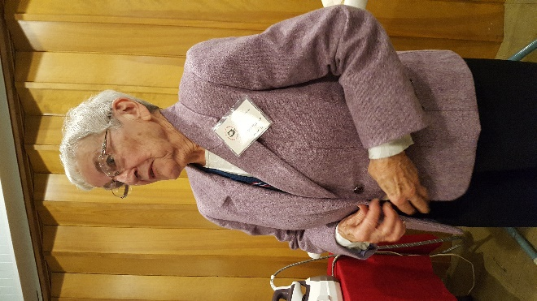

Mabel Wagner

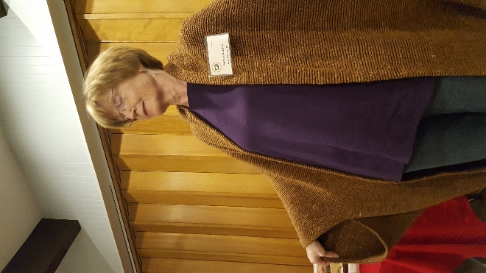

Pat Keenan

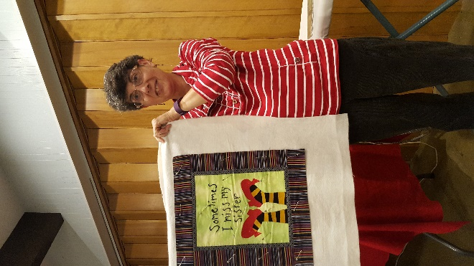

Denise Carlson

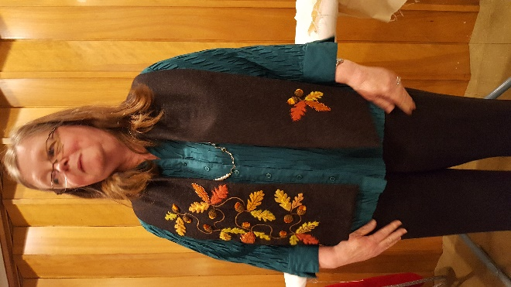

Donna Boucher

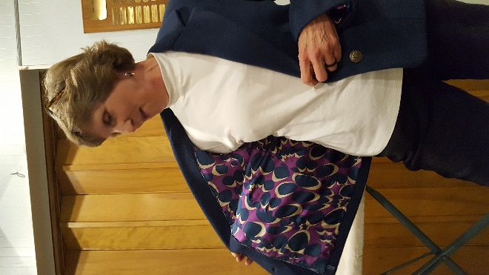

Donna Mansolillo and her fun lining.

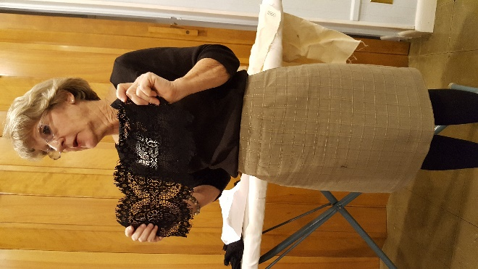

Diane Martin

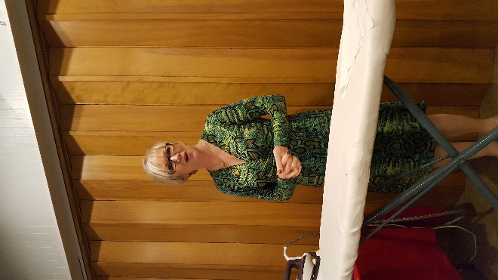

Ann Steeves

November presenter

The Pressinatrix!

Thank you Rose O’Koren for submitting photographs.