**Refreshments**

Refreshments are provided at all meetings and members provide the baked goods or appetizers as well as help with setting up and cleaning up. RISN uses a calendar for members to provide refreshments. The first letter of your last name determines the monthly meeting for which you are requested to support refreshments. Members providing refreshments will receive an additional raffle ticket for the meeting raffle. Be sure to mention this upon check-in!

**November Refreshments: E through H**

Nancy Spirito is our Refreshments Chairperson and may be contacted at:

[bridalfinerydesign@gmail.com](mailto:bridalfinerydesign@gmail.com)

**For Sale or Free**

Your unwanted fabric, patterns, notions, or publications may be inspiration to a member. Members are invited to set up a table at our meetings to sell or give away sewing/craft related items.

Have a sewing/craft related business? Why not consider showcasing/selling your items at a meeting? Please limit your selling space to one table.

**DIRECTIONS TO GREENWICH CLUB**

**From the South**: Take 95 North to exit 8A (Rt. 2 Warwick/E. Greenwich). Stay on Rt.2, go to the traffic light at the Showcase Cinema, take a left onto Division Street (Rt. 401), follow to 2nd traffic light, and take right onto Post Road/Rt. 1. The Greenwich Club, 5426 Post Road, is on your left.

**From the North**: Take 95 South to exit 9 (Rt. 4 South). Take the first exit which will bring you to Rt. 401 (E. Greenwich/Division St.). At the end of the exit ramp facing straight, take a right turn onto Division Street. **Continue to follow above directions once on Division Street.**

**Executive Board**

**EXECUTIVE SECRETARY**

Mary Jo Hines

(401-785-9001

[maryjo.hines@gmail.com](mailto:maryjo.hines@gmail.com)

**TREASURER/REGISTRATIONS**  
Ann Pericolo

(508-846-5456)

[AnnPericolo@yahoo.com](mailto:AnnPericolo@yahoo.com)

**NEWSLETTER MAILINGS**  
Mary Morse  
( 401-821-7467)

[memorse@yahoo.com](mailto:memorse@yahoo.com)

**PROGRAM CHAIRPERSON**  
Diane Martin  
(401-762-0960)

[dma426@aol.com](mailto:dma426@aol.com)

**NEW YORK TRIP**

Michele Ferguson

(401-845-2069)

micheleferguson81@yahoo.com

**REFRESHMENTS CHAIRPERSON**  
Nancy Spirito

(401-965-6556)

[bridalfinerydesign@gmail.com](mailto:bridalfinerydesign@gmail.com)

**WEB ADMINISTRATOR**  
Maureen Rozes

(401-855-5885)

[maureenrozes@yahoo.com](mailto:maureenrozes@yahoo.com)

**FACEBOOK ADMINISTRATOR**

Robbin Donahue

[robbindonahue@gmail.com](mailto:robbindonahue@gmail.com)

**NAME TAGS/MEMBERSHIP CARDS**

Susan Love

(401-595-1160)

SchoolHouseStudio@verizon.net





**November Meeting**

**November 7, 2017**

For our November program “Gorgeous Fabrics Pressing Tips”, RISN welcomes Ann Steeves, founder and owner of [*Gorgeous Fabrics*](http://www.gorgeousfabrics.com/)*,* an online fabric store that services the home sewing enthusiast and small and mid-size designers. Ann has been sewing clothing since age 12. She has been a sample maker for numerous designers. Ann is a sewing instructor, contributor to Threads Magazine and former contributing editor to Sew Stylish Magazine. She actively blogs at blog.gorgeousfabrics.com, where you can read articles written by both Ann and her alter-ego The Pressinatrix.

Pressing properly can make all the difference between a garment that looks so-so and one that looks spectacular. In her presentation, Ann will demonstrate techniques and tools that will give you professional results and take your garments and projects to the next level.

To learn more about Ann and her business visit:

[www.gorgeousfabrics.com](http://www.gorgeousfabrics.com/)  
[blog.gorgeousfabrics.com](http://blog.gorgeousfabrics.com/)

**Congratulations to Rose O’Koren who won our Early Registration Raffle. Rose’s prize was a Steamfast Travel Iron**

**October Show and Share**

Mary Jo Hines opened the meeting by introducing RISN’s board members for this year.

She also described the RISN charity sewing project for the year. RISN members are encouraged to sew vests for premature infants at Women and Infants Hospital. Robbin Donahue explained the new member benefit of an invitation only RISN Facebook page.

Our members were certainly busy since our last meeting in May with projects. Naomi Lipsky opened our Show and Share with a dress she created for her daughter’s 16th century themed wedding. The flowing sleeves were fashioned from interesting flower embellished fabric. Diane Martin showed her completed Mother of the Bride dress which she wore this summer for her daughter’s wedding. Diane purchased the lace on Etsy and it came from Latvia. Denise Carlson modeled a lycra knit top from a Kristine Johnson pattern #1025 on which she used a cover stitch. Carolyn Gazerro shared a shirt and skirt reversible ensemble and a jacket and skirt set which was a work in progress. Rose O’Koren offered a shopping bag she created and embellished with decorative stitching on the webbing. She also shared a wrap dress made from a freebie pattern. Jane Hedley wore a very interesting skirt created from a black and white swirly pattern fabric and using a Stylelark pattern. Jerilyn Perry shared that her sewing school created toiletry bags for hurricane victims. Mary Jo announced that Sew Seeds of Love is back in action. Please reach out to her if interested in this charity sewing group. Rose O’Koren asked for member support for her ASG project, now in its seventh year making clothes for 18 inch dolls that are given to girls in shelters, etc. Rose is asking for donations of 18 in. dolls. Susan Love’s sewing school is supporting Rose’s project by sewing sleeping bags for the dolls and is asking for donations of fabric.

**RISN Facebook Update**

Robbin Donahue, our Facebook page administrator, reports that 39 RISN members have joined this exclusive member page. Members are already posting and commenting about sewing projects. Have questions? Please contact Robbin. Also email Robbin if you have not yet received an invitation to join.

**RISN Meetings**

**GREENWICH CLUB**

**5426 Post Road**

**East Greenwich, Rhode Island**

**02818**

**First Tuesday of the Month**

**@ 7:00 pm**

**֎ ֎ ֎ ֎ ֎**

**RISN 2017-2018**

**Future Meeting Dates and Presenters**

**December 5, 2017 "The Origin of Linen, Cashmere and Silk and the Art of Garment Grooming"** Reed McLaren; [www.facebook.com/THEHOUSEOFAMA/](http://www.facebook.com/THEHOUSEOFAMA/) and [www.instagram.com/thehouseofama/](http://www.instagram.com/thehouseofama/)

**March 6, 2018 "Sewing for Historic Interiors"** Clarissa de Muzzio

**April 3, 2018 "Process: Inspiration to Runway; Making a collection with custom textiles and hand-dyed fabrics”** Susan Troy

**May 1, 2018 "Orange Lingerie”**

Norma Lochr; [norma@orange-lingerie.com](mailto:norma@orange-lingerie.com)

**New York City Shopping Trip**

**June 6, 2018**

**֎ ֎ ֎ ֎ ֎**

**November Program Highlights**

Our October program, “**Traveling** **Tailor to the Stars**” featured Robin Chalfin. Robin is a lifelong sewer who says she was driven to sew as a child. Her first sewing job was with the Boston Ballet costume shop which provided her with a great education. She began as a piecer, moved up to fitting, and then became a cutter. From this experience she realized that costume was where she wanted to focus. She enjoyed the group effort and found it less competitive than the fashion world.

Her pivotal point was when the Rolling Stones came to Boston and needed stitchers for some unfinished work. She jumped at the chance. From this experience she came up with the concept of a traveling seamstress. She has found great success with this business model because she works to develop a trusting relationship with clients. She believes that people deserve to look good and feel good in what they wear. She makes sure to approach challenges in a calm manner. Her best advice for fitting is to tell people the truth.

Robin continues to work in the entertainment world and is a part time instructor at the Massachusetts Art Institute. Her work has led her to earn the “Best Tailor in Boston” award from Boston magazine.

Robin’s advice for anyone looking to sew in the entertainment world is to get experience at a theater or dress shop. The next step is to find a sponsor and join a film union.

Robin’s greatest lesson is to say “Yes” to opportunities. Let’s look for her name in movie credits!

**Membership Cards**

Members who registered at the October meeting can pick up their membership card at the November meeting. Any unclaimed membership cards will be mailed out following the November meeting. Please remember to turn in your name tag at the end of each meeting.

Membership information and forms can be found on our website: [www.rhodeislandsewingnetwork.com](http://www.rhodeislandsewingnetwork.com)

**RISN Service Project**

Our RISN Charity Project for 2017-2018 is preemie vests for babies born prematurely and must remain in medical care at the Women and Infants Hospital NICU. Sewn in soft flannel, they are secured with a velcro closure on each side, with flaps that can be opened to access monitors and medical gear. The vests must be sewn according to the directions because the style, fabric, and fabrication have all been approved for their usage. RISN members should have received the email with pattern and instructions for making the vests. If you have questions, contact Mary Jo Hines at

[maryjo.hines@gmail.com](mailto:maryjo.hines@gmail.com)

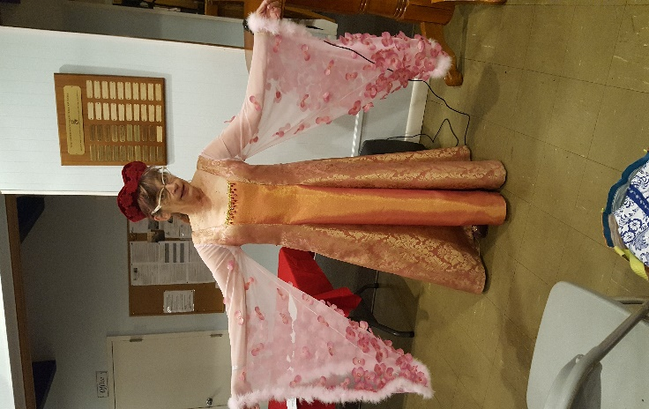

Naomi Lipsky

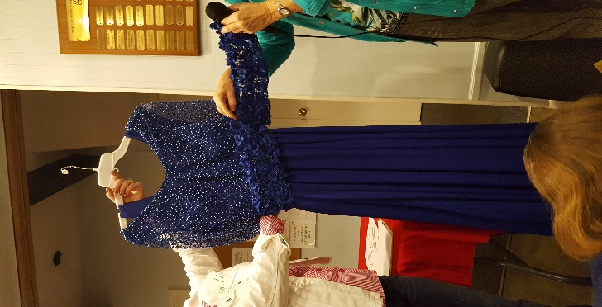

Diane Martin

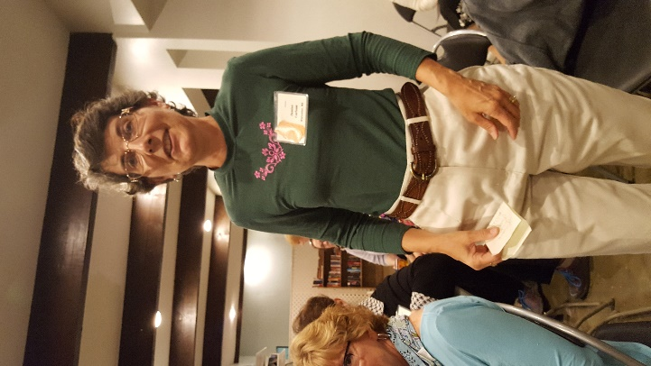

Denise Carlson

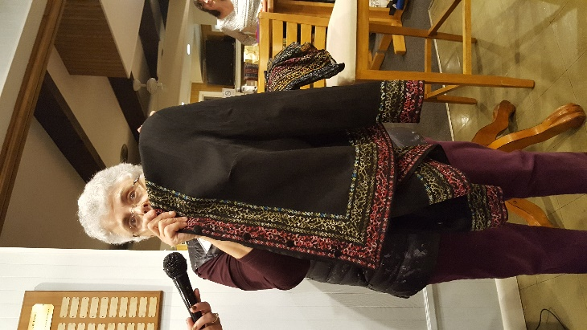

Carolyn Gazerro

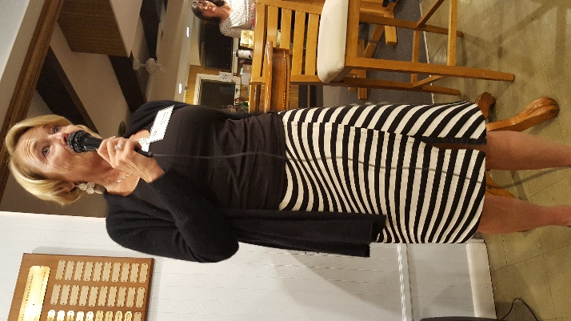

Jane Hedley

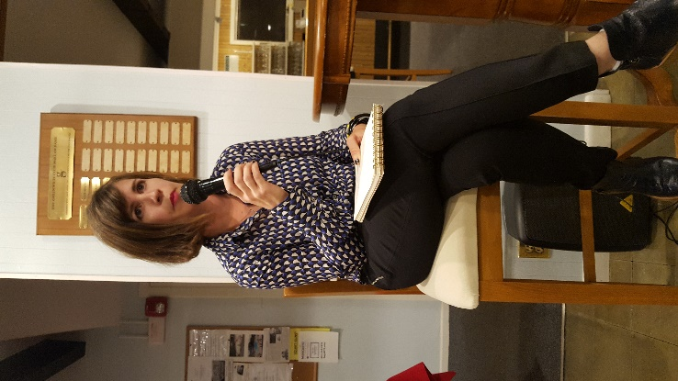

Presenter: Robin Chalfin