**Refreshments**

RISN uses a calendar for members to provide refreshments and help with cleaning up. The first letter of your last name determines the monthly meeting for which you are requested to support refreshments. Members providing refreshments will receive an additional raffle ticket for the meeting raffle. Be sure to mention this upon check-in!

**March Refreshments: M through P**

Nancy Spirito is our Refreshments Chairperson and may be contacted at:

[bridalfinerydesign@gmail.com](mailto:bridalfinerydesign@gmail.com)

**For Sale**

Did you do some stash cleaning during the

Blizzard? Please consider offering sewing/craft

related items for sale at our meetings. Freebies are

always appreciated!

Have a sewing/craft related business? Why not

consider showcasing/selling your items at a

meeting? Please limit your space to one table.

**DIRECTIONS TO GREENWICH CLUB**

**From the South**: Take 95 North to exit 8A (Rt. 2 Warwick/E. Greenwich). Stay on Rt.2, go to the traffic light at the Showcase Cinema, take a left onto Division Street (Rt. 401), follow to 2nd traffic light, and take right onto Post Road/Rt. 1. The Greenwich Club, 5426 Post Road, is on your left.

**From the North**: Take 95 South to exit 9 (Rt. 4 South). Take the first exit which will bring you to Rt. 401 (E. Greenwich/Division St.). At the end of the exit ramp facing straight, take a right turn onto Division Street. **Continue to follow above directions once on Division Street.**

**Executive Board**

**EXECUTIVE SECRETARY**

Mary Jo Hines

(401-785-9001

[maryjo.hines@gmail.com](mailto:maryjo.hines@gmail.com)

**TREASURER/REGISTRATIONS**  
Ann Pericolo

(508-846-5456)

[AnnPericolo@yahoo.com](mailto:AnnPericolo@yahoo.com)

**NEWSLETTER MAILINGS**  
Mary Morse  
( 401-821-7467)

[memorse@yahoo.com](mailto:memorse@yahoo.com)

**PROGRAM CHAIRPERSON**  
Diane Martin  
(401-762-0960)

dianemartin426@gmail.com

**NEW YORK TRIP**

Michele Ferguson

(401-845-2069)

micheleferguson81@yahoo.com

**REFRESHMENTS CHAIRPERSON**  
Nancy Spirito

(401-965-6556)

[bridalfinerydesign@gmail.com](mailto:bridalfinerydesign@gmail.com)

**WEB ADMINISTRATOR**  
Maureen Rozes

(401-855-5885)

[maureenrozes@yahoo.com](mailto:maureenrozes@yahoo.com)

**FACEBOOK ADMINISTRATOR**

Robbin Donahue

[robbindonahue@gmail.com](mailto:robbindonahue@gmail.com)

**NAME TAGS/MEMBERSHIP CARDS**

Susan Love

(401-595-1160)

[SchoolHouseStudio@verizon.net](mailto:SchoolHouseStudio@verizon.net)





**March Meeting**

**March 6, 2018**

Please join RISN for our March program, “*Sewing for Historic Interiors*” presented by Clarissa DeMuzio.

Clarissa deMuzio has been creating soft furnishings for historic interiors for 25 years. Her projects have included work for 17th century Dutch New York museum period rooms through a mid-century modern style apartment. Her talk will focus on favorite projects from four centuries: how designs were selected, materials were found and fabrication techniques appropriate for each period were utilized.

Clarissa has had a life-long love of sewing and textiles. She began sewing with her grandmother and is largely self-taught. Her work is on permanent display at the Metropolitan Museum of Art, the H.F. DuPont Museum and Library, Homewood House at Johns Hopkins University, and in many private homes across the country.

**December Show and Share**

Our December meeting opened with a special birthday recognition for Alice Erdmann who celebrated her 94th birthday. She received a cake and poinsettia.

Show and Share was led off by Mary Jo Hines sharing samples of the preemie vests service project. Nancy Hoell serged a symmetric jacket using McCall 7199. She also wore a metallic knit top made from a Cashmerette pattern and pants from ponte knit using a StyleLark pattern which she receive free for signing up for their newsletter.

Robbin Donahue shared a tote bag with streetscape embroidery and sample bags shown in cotton which are the projects for her MS 2 handbag class. Kathy Dacey presented a christening gown with a lace jacket made from Varisima Cotton. Heirloom techniques included pin tucks and insertion lace. Donna Mansolilo showed a little black dress “work in progress” which featured 60 beads along the back hand picked zipper. Rowena Burke modeled a grey sweatshirt dress which represented her first experience sewing with a digital pattern. Pockets cut with the dress and not a separate piece were a unique pattern feature. She found the pattern in an online publication “Peppermint” magazine which features free pattern downloads. Mary Jo showed 18 in doll clothing samples which is another Sew Seeds of Love project. Please contact her if interested. Rose O’Koren sent her thanks to RISN members for their support of her ASG holiday project. The group was able to provide 110 dolls with a wardrobe and accessories for the holidays.

Thank you to Kaleigh Guay for submitting photos from our December meeting Show and Share!

**Facebook Update**

RISN Exclusive Facebook group has already grown to 49 members and we have begun sharing projects, ideas, tips, short videos, and sewing related news. Come join the fun! Please contact Robbin Donahue if you have any questions or wish to join.

**RISN Service Project Update**

Mary Jo Hines asks members to keep working on the Preemie Vests for donation to NICU at Women and Infants Hospital. Completed vests can be brought to any RISN meeting. Please contact Mary Jo for a pattern and instructions.

**RISN Meetings**

**GREENWICH CLUB**

**5426 Post Road**

**East Greenwich, Rhode Island**

**02818**

**First Tuesday of the Month**

**@ 7:00 pm**

**֎ ֎ ֎ ֎ ֎**

**RISN 2017-2018**

**Future Meeting Dates and Presenters**

**March 6, 2018 "Sewing for Historic Interiors"** Clarissa de Muzzio

**April 3, 2018 "Process: Inspiration to Runway; Making a collection with custom textiles and hand-dyed fabrics”** Susan Troy

**May 1, 2018 "Orange Lingerie”**

Norma Lochr; [norma@orange-lingerie.com](mailto:norma@orange-lingerie.com)

**New York City Shopping Trip**

**June 6, 2018**

**Michele Ferguson will discuss trip details at our March meeting.**

**Do you have fabric or notions purchased on one of RISN’s previous New York trips?**

**Please bring your New York items or projects made from fabric purchased in New York to the March meeting for a special Show and Share.**

**֎ ֎ ֎ ֎ ֎**

**December Program Highlights**

Our December program “*The Origin of Linen, Cashmere and Silk and the Art of Garment Grooming”* was presented by Reed McLaren, owner of THE HOUSE OF AMA. “Ama” is a Japanese term describing women who free dive into the sea to gather pearls to sell. Reed’s jewels are the many vintage, designer garments made of natural materials in her collection.

Reed opened her program by reviewing the characteristics of natural fibers such as breathability, temperature regulation, hypoallergenic quality, durability, and decomposition and applied these characteristics to understanding linen, cashmere, and silk.

Reed has developed efficient grooming techniques to resuscitate and maintain her collection of vintage garments. She described various processes and products that she uses to revitalize her garments. She avoids dry cleaning for garments made from natural materials. Reed counseled that when hand washing to NOT wring out the garment but to gently squeeze out the moisture. To mend a hole she felts the piece using wool roving or depilled pieces from the garment. A white pillowcase makes an excellent garment bag in which to wash vintage items but only on the delicate wash cycle. She uses a Jilly model steamer as a natural sanitizer on her garments. A lint brush is great for restoring the nap to vintage textiles. Reed makes her own sweater combs from drywall screen and reclaimed exotic wood. (Please contact Reed at thehouseofama.com to order a comb.) Through the evening Reed shared many of her favorite garments from her collection. RISN members left the meeting with a robust set of strategies for breathing new life into vintage garments.

**On the Web with RISN**

<http://www.rhodeislandsewingnetwork.com>

The RISN website has a new look with all the resources you need to stay connected with RISN happenings. You'll find meeting dates, speakers, Master Seamstress info, New York trip details, the newsletter, and a Gallery tab that will feature photos from meetings and other RISN events. Resources, such as fabric stores, are also featured on the site. Maureen Rozes is the new Web Administrator and welcomes your feedback.

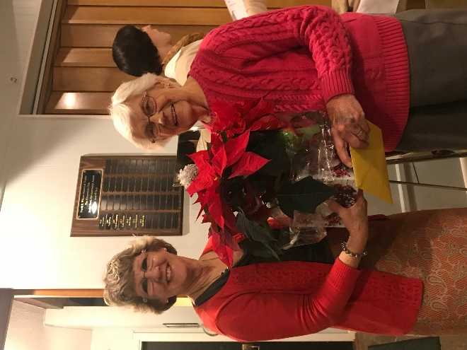

**Diane Martin presenting**

**Alice Erdmann with her birthday poinsettia**

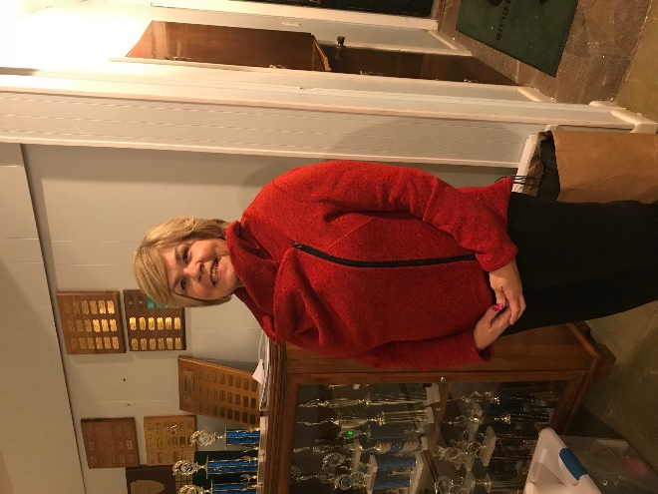

**Nancy Hoell wearing her serged jacket**

**Photos from December Meeting**

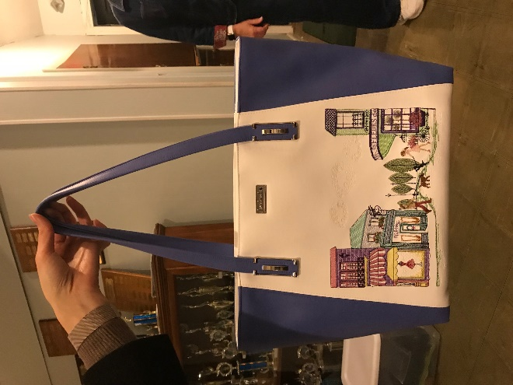

**Robbin Donahue handbag creation**

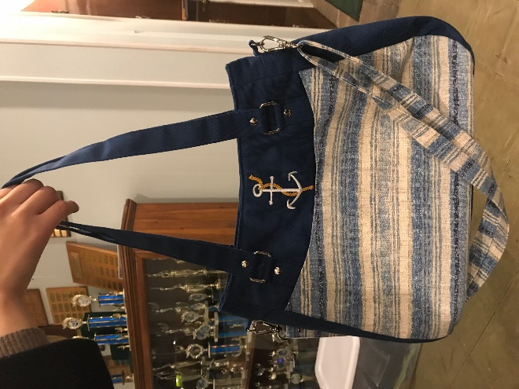

**Another Robbin Donahue handbag creation**

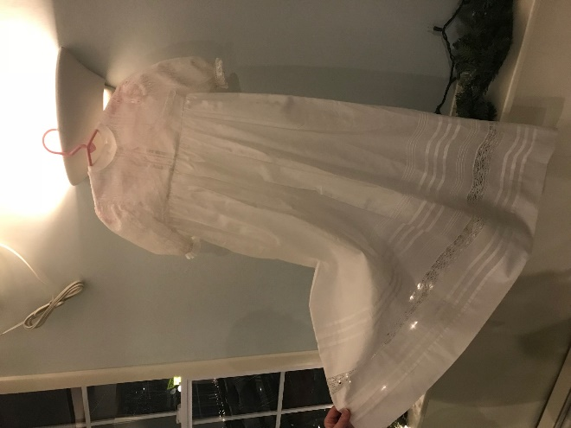

**Kathy Dacey Christening Gown**

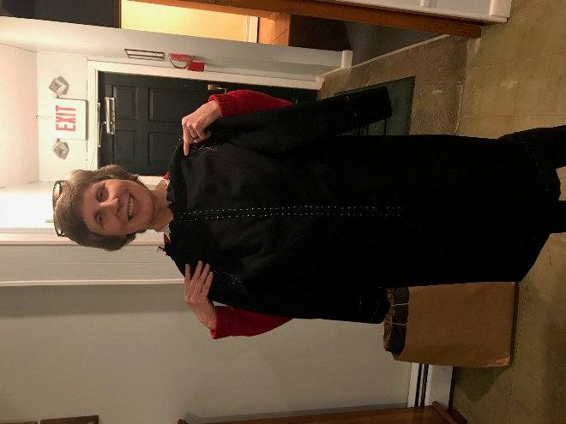

**Donna Mansolilio with her Little Black Dress in progress**